***Test Pyramid***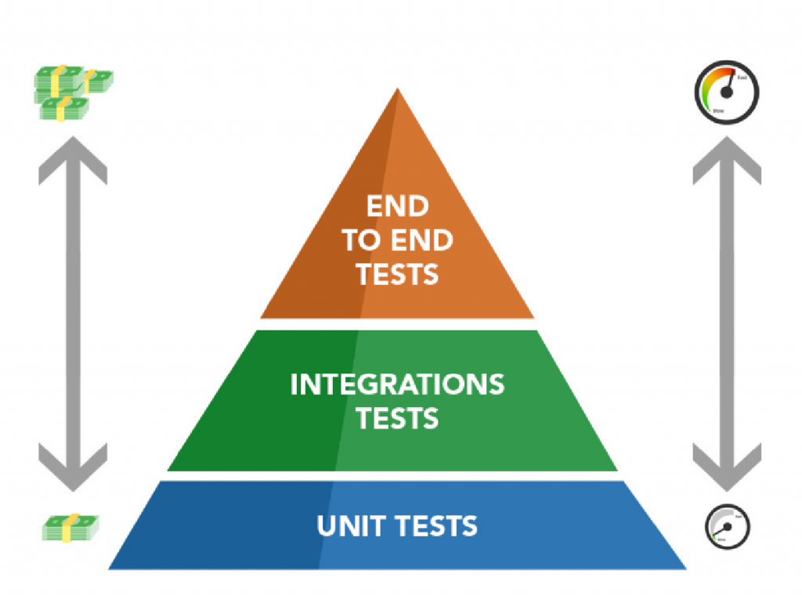

*The further down the pyramid, the faster the test run, therefore, consequently, the test becomes cheaper and less costly to apply, and the higher up in the pyramid, the longer, more costly and expansive the test becomes.*

**Unit Tests**: are fast and inexpensive, test the smallest parts of a system;

**Integration Tests:** verifies that the integrations are correct, that is, verifies the stability and functionality of system integration with another;

**End to End Tests:** Tests the entire software, from start to finish, covering all features, integrations and applications;

***The higher on the pyramid:***

***+Fragile;***

***+Slow;***

***+External validations***

***+Complexe to building***

***+Comprehensive***

***Black Box***

***Testing***

*It is based on the basic requirements of the software, focusing on the application requirements, that is, on the actions that must be performed. Black box testing levels are integration, system, acceptance, alpha and beta. They have methods and classes, command and repetition and conditions. It boils down to input and output tests.*

* No knowledge about the system
* Greater number of test combinations
* Trial and error methodology
* Simple to perform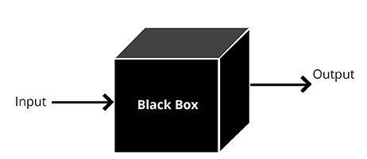

**White Box**

**Testing**

It has access to the source code, knowing the internal structure of the product. Being analyzed and making it possible to choose specific parts of a component to be evaluated, allowing a precise search of the behavior of the structure.

* Full knowledge of the system
* Very specialized tests
* Test focused on a single and small functionality
* More complex to build

**Grey Box**

**Testing**

Gray box testing. The purpose of this test is to look for defects, if any, due to improper structure or improper use of the applications.

* Partial knowledge of the system;
* Structure-Oriented testing;
* Test the limitations;